**Topic:** Archimedes of Syracuse

**Notes on Topic:** Euclid and Archimedes were separated by two or three generations  
After Archimedes days the world would not see a great mathematician like him for 2000 years  
Many of his mathematical works and prefaces have survived through history, fortunately.

He is the son of an Astronomer and was studying the skies from a young age.  
He also spent some time in Egypt and studied at the great Library of Alexandria, the base of Euclid’s operations, he was trained in the Euclidean tradition.  
One of his early inventions is called the “Archimedean screw” a device for raising water, used to access water during drought months in Egypt, this device is still used today  
The dual nature of Archimedes’ genius: the practical, down-to-earth matters, or delving into the most abstract, ethereal realm  
Archimedes chose to return to his hometown of Syracuse despite the scholarly nature of Alexandria  
His mathematical talent was augmented by his ability to approach any problem at hand with periods of intense, focused concentration, more mundane concerns of life were ignored

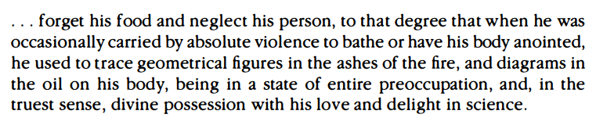

Archimedes was called on by King Hieron for his scientific mind: once in wanting to discover whether or not his goldsmith had given him a lesser alloy instead of gold, that’s how Archimedes discovered the fundamental principles of hydrostatic, leaving a treatise titled On Floating Bodies about this topic

He advanced the science of optics and did pioneering work in mechanics, with his water pump and his work with levers, pulleys and compound pulleys  
When Rome, under the leadership of Marcellus, attacked Syracuse, Archimedes defended his homeland by designing weaponry of great effectiveness -- a one-man military-industrial complex

**suggest the students read the bit on Plutarch’s writings on Marcellus and Archimedes at war**

“In this transport of study and contemplation, a soldier, unexpectedly coming up to him, commanded him to follow Marcellus; which he declining to do before he had worked out his problem to a demonstration, the soldier, enraged, drew his sword and ran him through,” Plutarch on Archimedes death in his writings of Marcellus.  
“He died as he had lived, lost in thought about his beloved mathematics,” JTG 88  
Of all his practical inventions and scientific discoveries, his true passion was mathematics

**Additional Suggested Reading**: Plutarch’s writings on Archimedes, JTG 86-88

**Assignment:** None